Tutorial – 6.2

**Aim:** Write a shell script which will generate first n Fibonacci numberslike:1, 1, 2, 3,5,8,13,...

**Code:**read num

a=0

b=1

i=2

echo -e "$a\n$b"

while [ $i -lt $num ]

do

i=`expr $i + 1 `

z=`expr $a + $b `

echo "$z"

a=$b

b=$z

done

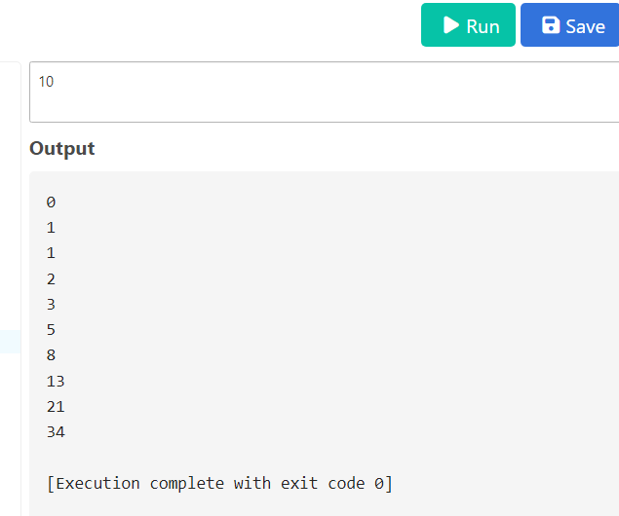**Output:**